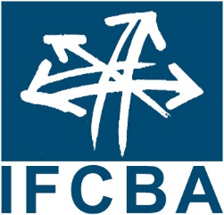 | International Federation of  Customs Brokers Associations  30 April-1 May 2019

Registration Form – 2019 IFCBA Board of Directors Meeting

Thon Hotel Brussels City Centre, Brussels, Belgium

Avenue du Boulevard 17, 1210 Brussels

Please complete a separate form for each delegate attending.
Meeting Registration DEADLINE: April 19, 2019

Attendees are required to make their own accommodation arrangements. If you prefer to stay at the Thon Hotel, please use this link: https://www.thonhotels.com/our-hotels/belgium/brussels/thon-hotel-brussels-city-centre

Please return your completed form to the IFCBA Secretariat by email to ifcba@ifcba.org, or by fax to 613 562-3548.

Delegate Information
Name of organization that you are representing:
Title: |  | Ms. Mrs. Mr. Other:_____________
Family Name:
First/Given name:
Business Address:
Phone:
Email:
Visa Support Letter Required: Yes

Registration Packages | Cost
Delegate Package: includes meetings, breaks and lunches on April 30 & May 1. Please note that attendance at the Board of Directors and Annual Meetings is restricted to representatives of IFCBA member associations only. | $US 495.00  per person
TOTAL: | $

Will you be attending the WCO HS Conference – May 2-3? Yes No
Please note there is no charge for the conference. Here is the link to the program:
http://www.wcoomd.org/-/media/wco/public/global/pdf/events/2019/program-guide_hs-conference.pdf?la=en
Here is the link to register: http://www.wcoomd.org/en/events/upcoming-events/hs-review-conference/registration.aspx
Please note that space may be limited.

Credit Card Information

Payment method: VISA MASTERCARD AMEX
Name on card:

Card Number: |  | Expiration date:

Cancellation policy: No refund for cancellation after April 5, 2019. Registrations however are transferrable.

